Day5:

Class exercise – 1:

package com.testing.demo;

import io.github.bonigarcia.wdm.WebDriverManager;

import org.openqa.selenium.By;

import org.openqa.selenium.WebDriver;

import org.openqa.selenium.WebElement;

import org.openqa.selenium.chrome.ChromeDriver;

import org.openqa.selenium.chrome.ChromeOptions;

import org.openqa.selenium.interactions.Actions;

public class CE1 {

public static void main(String[] args) {

WebDriverManager.*chromedriver*().setup();

ChromeOptions co=new ChromeOptions();

co.addArguments ("--remote-allow-origins=*");

WebDriver driver=new ChromeDriver(co);

driver.get ("https://demoqa.com/droppable/");

driver.manage().window().maximize() ;

WebElement drag=driver.findElement(By.*id*("draggable"));

WebElement drop=driver.findElement(By.*id*("droppable"));

Actions a = new Actions(driver);

a.dragAndDrop(drag, drop).build().perform();

}

}

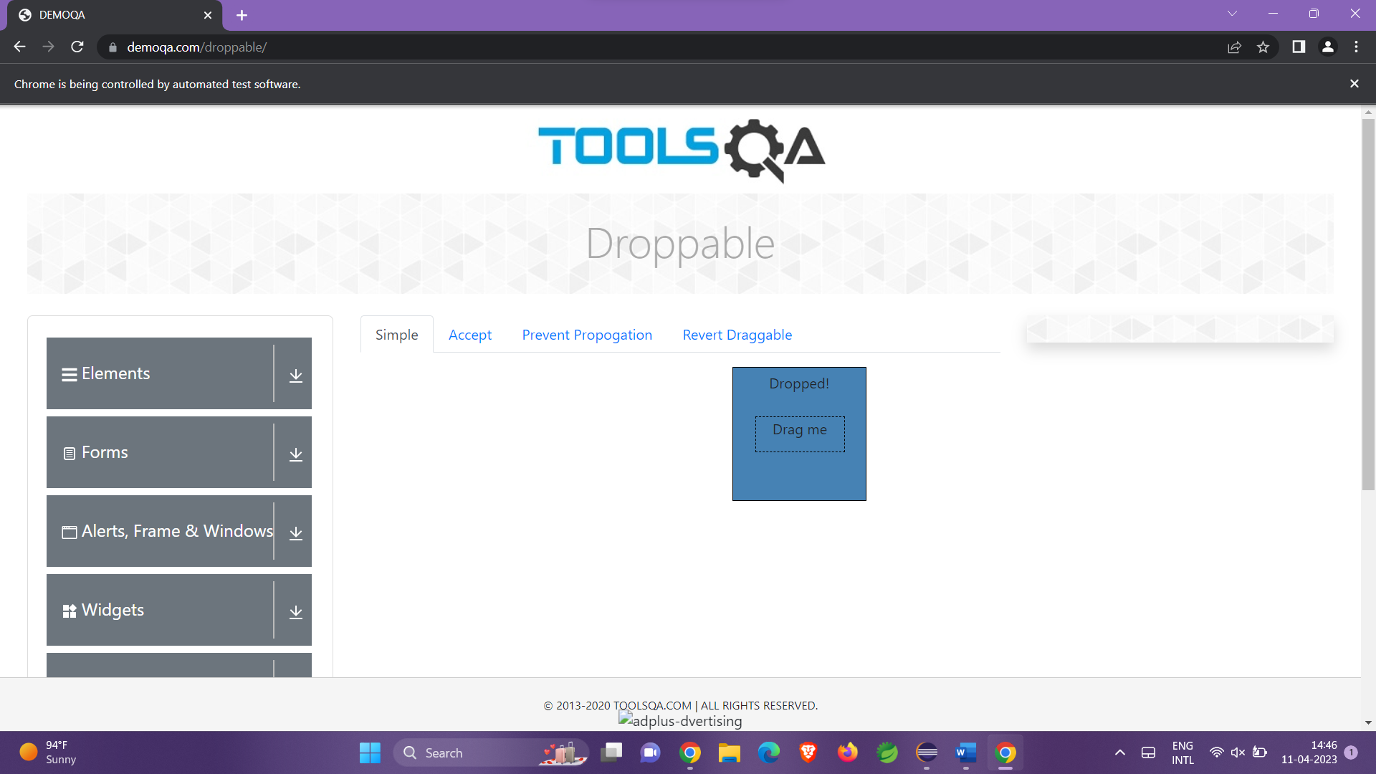

Class Exercise – 2:

package com.testing.demo;

import org.openqa.selenium.By;

import org.openqa.selenium.WebDriver;

import org.openqa.selenium.WebElement;

import org.openqa.selenium.chrome.ChromeDriver;

import org.openqa.selenium.interactions.Actions;

import io.github.bonigarcia.wdm.WebDriverManager;

public class ce2 {

public static void main( String[] args ) throws InterruptedException

{

WebDriverManager.*chromedriver*().setup();

WebDriver driver = new ChromeDriver();

driver.manage().window().maximize();

driver.navigate().to("https://jqueryui.com/droppable/");

driver.manage().window().maximize();

driver.switchTo().frame(0);

WebElement drag = driver.findElement(By.*id*("draggable"));

WebElement drop = driver.findElement(By.*id*("droppable"));

Actions a = new Actions(driver);

a.dragAndDrop(drag, drop).build().perform();

}

}

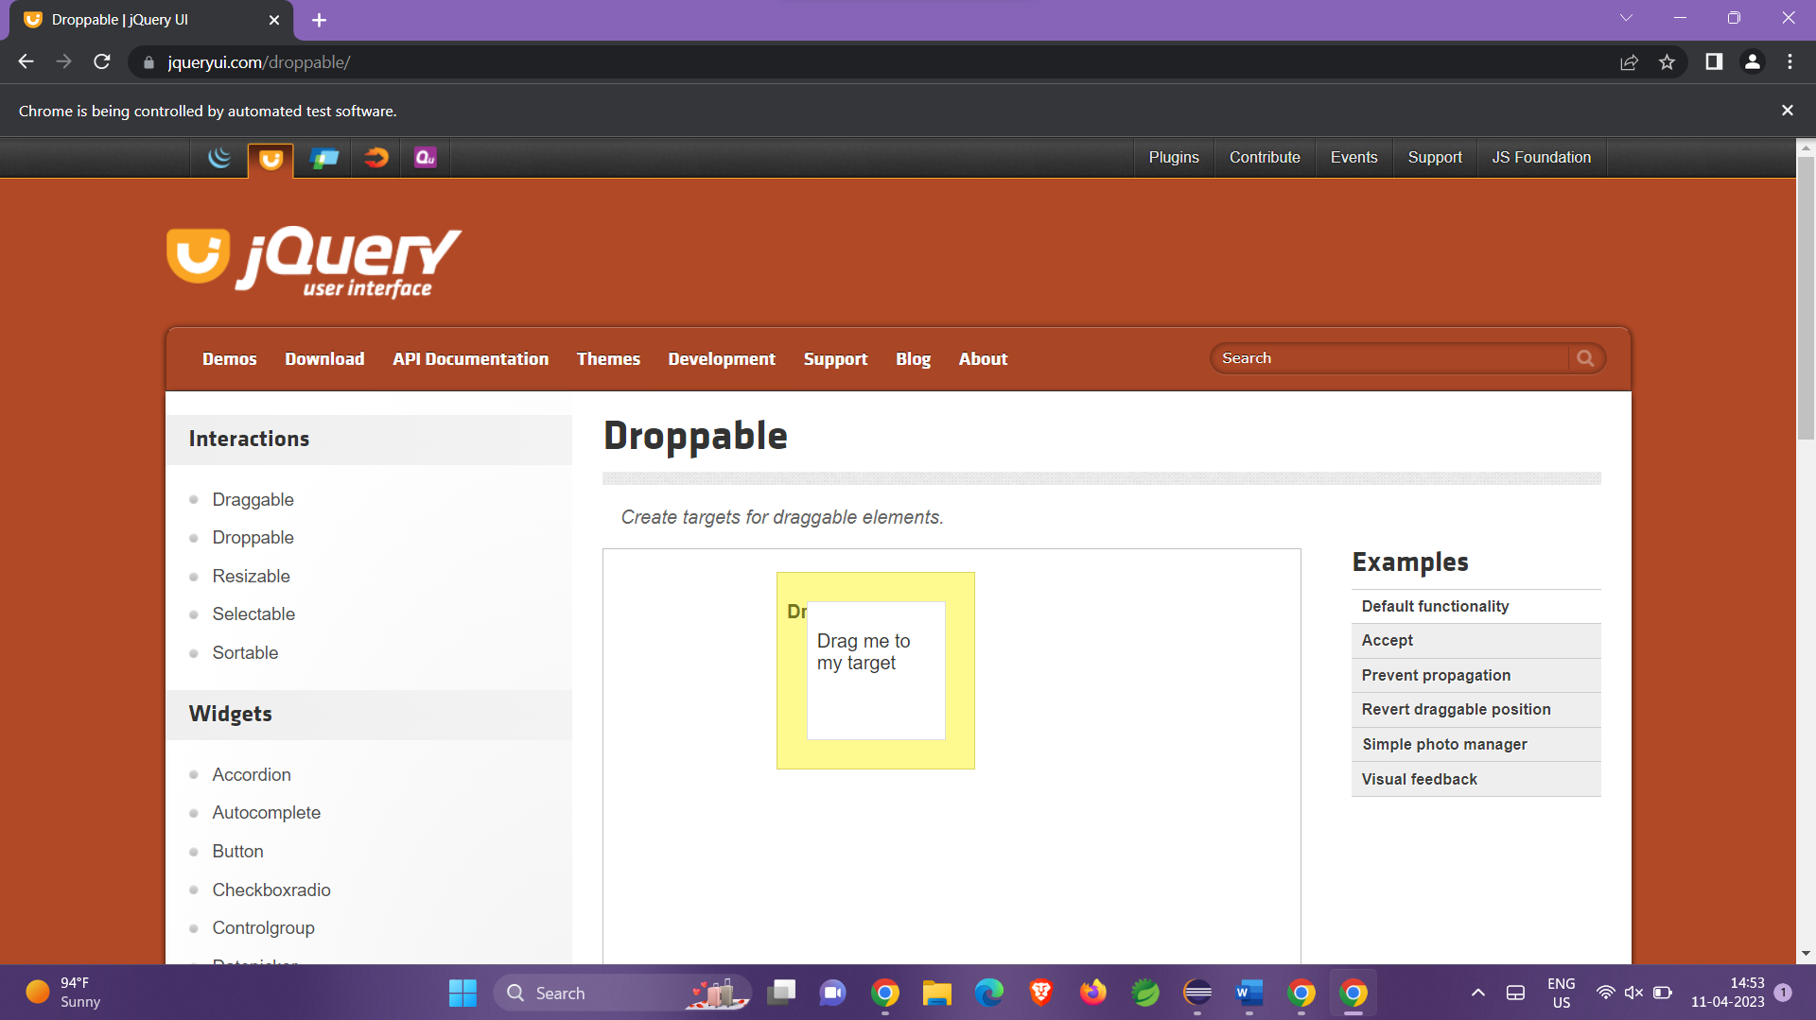

Class Exercise-3:

package com.testing.demo;

import org.openqa.selenium.Alert;

import org.openqa.selenium.By;

import org.openqa.selenium.WebDriver;

import org.openqa.selenium.WebElement;

import org.openqa.selenium.chrome.ChromeDriver;

import org.openqa.selenium.chrome.ChromeOptions;

import io.github.bonigarcia.wdm.WebDriverManager;

/**

* Hello world!

*

*/

public class D6CE3

{

public static void main( String[] args ) throws InterruptedException

{

WebDriverManager.*chromedriver*().setup();

ChromeOptions co=new ChromeOptions();

co.addArguments ("--remote-allow-origins=*");

WebDriver driver=new ChromeDriver(co);

driver.get ("https://demo.guru99.com/test/delete_customer.php");

WebElement txtBoxl=driver.findElement(By.*name*("cusid"));

txtBoxl.sendKeys("401");

WebElement submitBtn = driver.findElement(By.*name*("submit"));

submitBtn.click();

Alert alertl=driver.switchTo().alert();

Thread.*sleep*(3000);

alertl.dismiss();

txtBoxl.clear();

txtBoxl.sendKeys("402");

submitBtn.click();

Alert alert2=driver.switchTo().alert();

alert2.accept();

Alert alert3=driver.switchTo().alert();

String txt=alert3.getText();

alert3.accept();

System.***out***.println(txt);

}

}

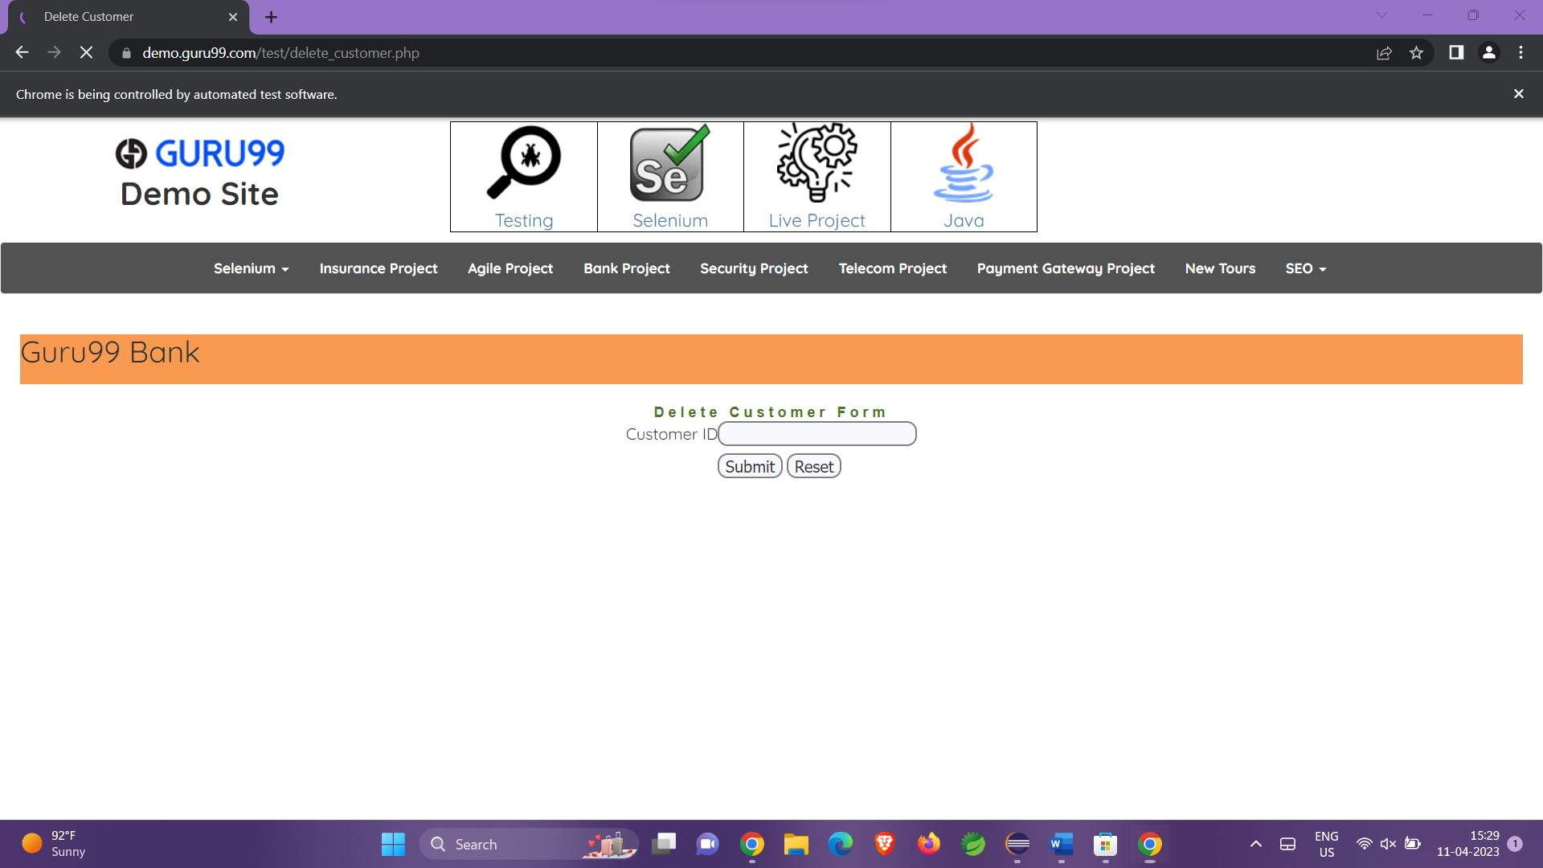

Class Exercise – 4:

package com.test.Day_5;

import org.openqa.selenium.Alert;

import org.openqa.selenium.By;

import org.openqa.selenium.WebDriver;

import org.openqa.selenium.chrome.ChromeDriver;

import org.openqa.selenium.chrome.ChromeOptions;

import io.github.bonigarcia.wdm.WebDriverManager;

public class ClassExcercise4 {

public static void main(String[] args)throws InterruptedException {

WebDriverManager.chromedriver().setup();

ChromeOptions co=new ChromeOptions();

co.addArguments ("--remote-allow-origins=*");

WebDriver d=new ChromeDriver (co);

d.get("https://www.abhibus.com/bus-ticket-booking");

d.manage().window().maximize();

d.findElement(By.xpath("//*[@id=\"source\"]")).sendKeys("Coimbatore");

d.findElement(By.xpath("//*[@id=\"destination\"]")).sendKeys("Chennai");

Thread.sleep(5000);

d.findElement(By.xpath("//*[@id=\"datepicker1\"]")).click();

d.findElement(By.xpath("//*[@id=\"ui-datepicker-div\"]/div[2]/table/tbody/tr[4]/td[1]/a")).click();

}

}

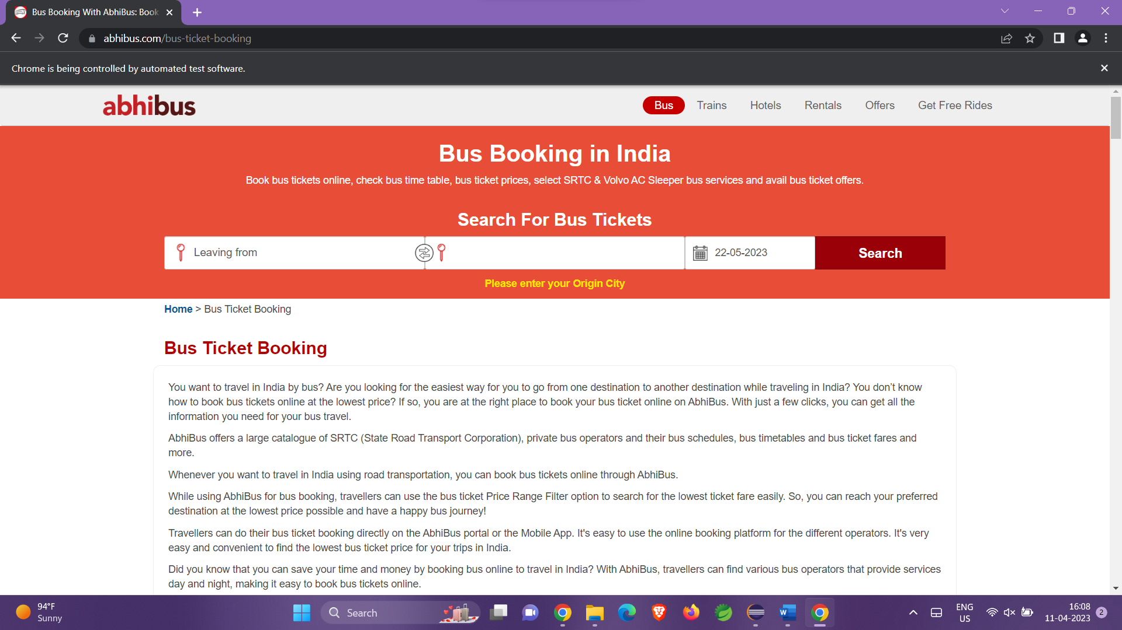

Class exercise -5

package com.testing.demo;

import org.openqa.selenium.By;

import org.openqa.selenium.Keys;

import org.openqa.selenium.WebDriver;

import org.openqa.selenium.WindowType;

import org.openqa.selenium.chrome.ChromeDriver;

import org.openqa.selenium.chrome.ChromeOptions;

import io.github.bonigarcia.wdm.WebDriverManager;

public class D5CE5 {

public static void main(String[] args) {

WebDriverManager.*chromedriver*().setup();

ChromeOptions co=new ChromeOptions();

co.addArguments ("--remote-allow-origins=*");

WebDriver driver=new ChromeDriver(co);

driver.get ("https://www.google.com");

driver.manage().window().maximize() ;

driver.findElement(By.*name*("q")).sendKeys("Apple");

driver.findElement(By.*name*("q")).sendKeys(*Keys*.***ENTER***);

System.***out***.println(driver.getWindowHandle());

System.***out***.println(driver.getTitle());

driver.switchTo().newWindow(*WindowType*.***TAB***);

driver.get("https://www.google.com");

driver.manage().window().maximize() ;

driver.findElement(By.*name*("q")).sendKeys("selenium");

driver.findElement(By.*name*("q")).sendKeys(*Keys*.***ENTER***);

System.***out***.println("\n"+driver.getWindowHandle());

System.***out***.println("\n"+driver.getTitle());

driver.switchTo().newWindow(*WindowType*.***TAB***);

driver.get("https://www.google.com");

driver.manage().window().maximize() ;

driver.findElement(By.*name*("q")).sendKeys("dell");

driver.findElement(By.*name*("q")).sendKeys(*Keys*.***ENTER***);

System.***out***.println("\n"+driver.getWindowHandle());

System.***out***.println("\n"+driver.getTitle());

}

}

